**Second Project**

Hello Sir/Mam,

My name is Rinki. I want to make make my trip like website.

The Front page of this website will be appear like this:-

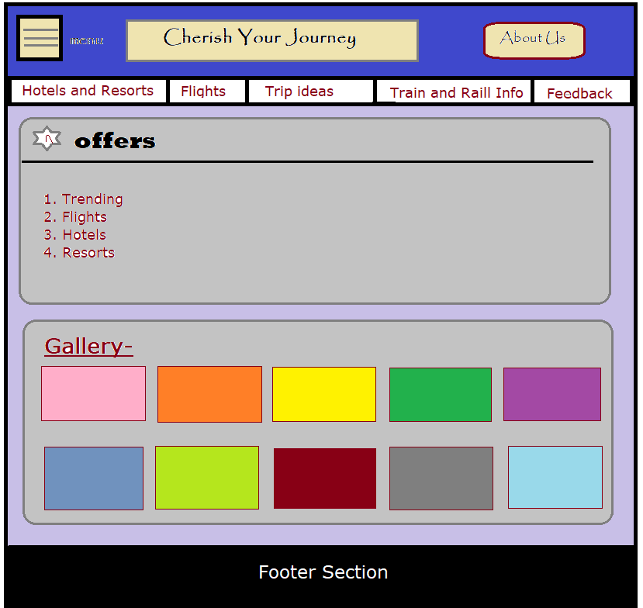

It is just a layout to make clear what are the things will be where.

**MENU**:- In the menu section, there are many categories like-

* View/Manage Trips
* Login
* Sign In
* My wallet(my payments)
* Settings
* Travel Offers

**About Us**: - In About Us section, first we will tell about our website, then the FAQ (frequently asked question) will be mention. This will going to help the other people to resolve their confusion as well as make easy them for whatever they want to do like arrange their trip and make payments and so on.

**Hotels and Resorts**: -In this, after giving details like location, check out, check in, Rooms, person, it will respond according to that.

Just select the hotels and then the payment section will get open. After that it will get add in **My Wallet** section.

Same as for we go through with **flights**, according the given details it will response.

**Trip Ideas**: - In this section, we describe the famous places of every state and country including historical places, cultural and religious places, Museums, Adventures places like things.

As well as image, related video and details of their places will be provided.

**Train and Rail Info**: - In this section, people can book train tickets. And check the information about rail as:-

* Check PNR
* See train schedule
* Live Train status
* Check Train Availability
* Live station
* Train Coach Position

**Feedback**: - In the feedback section, there will be mention comments of people. That will help to believe in us.

That’s all about my project.

Thank You